Peter Victoratos

CSC 411

March 1, 2018

Lab09 Features Writeup

1. Original Images

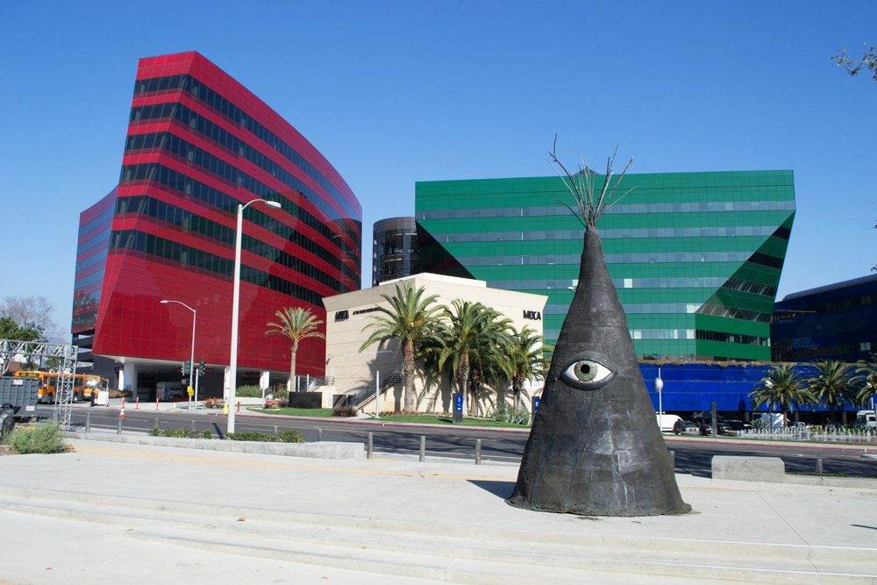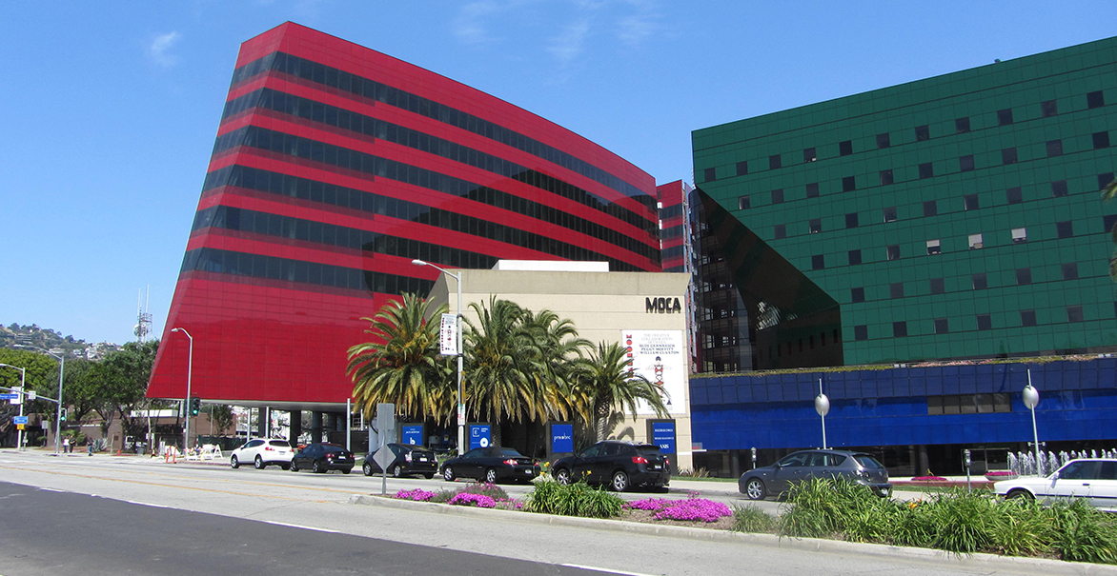

1. 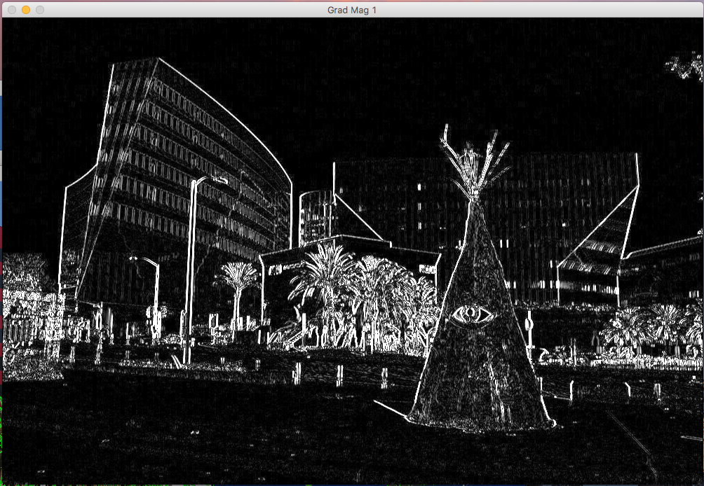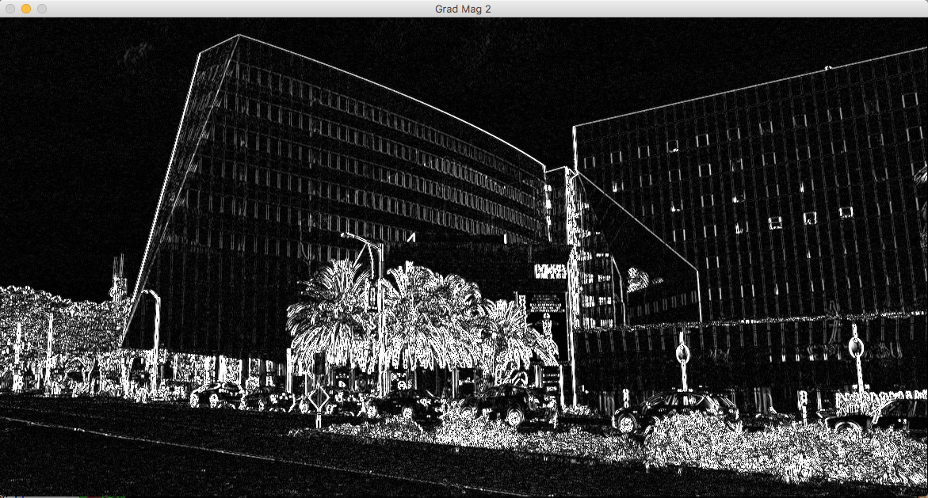Gradient Magnitudes

1. 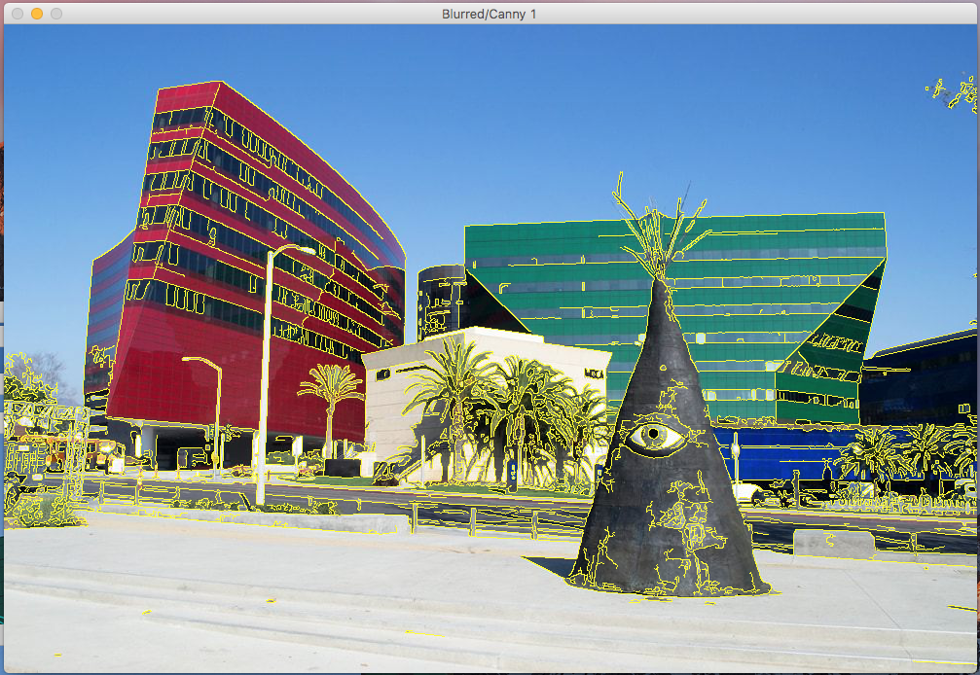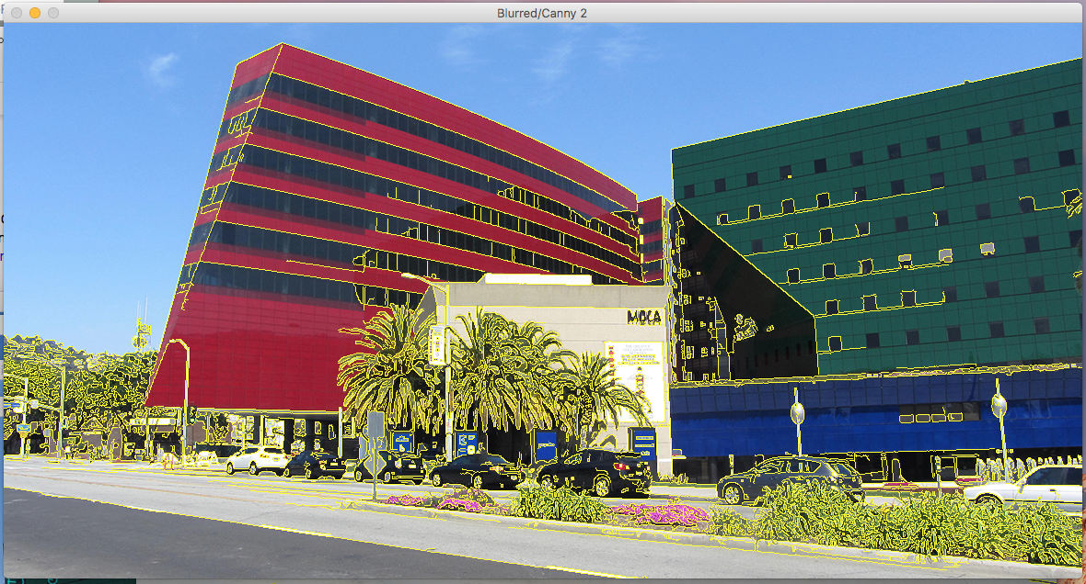Blurred/Canny Edges
2. 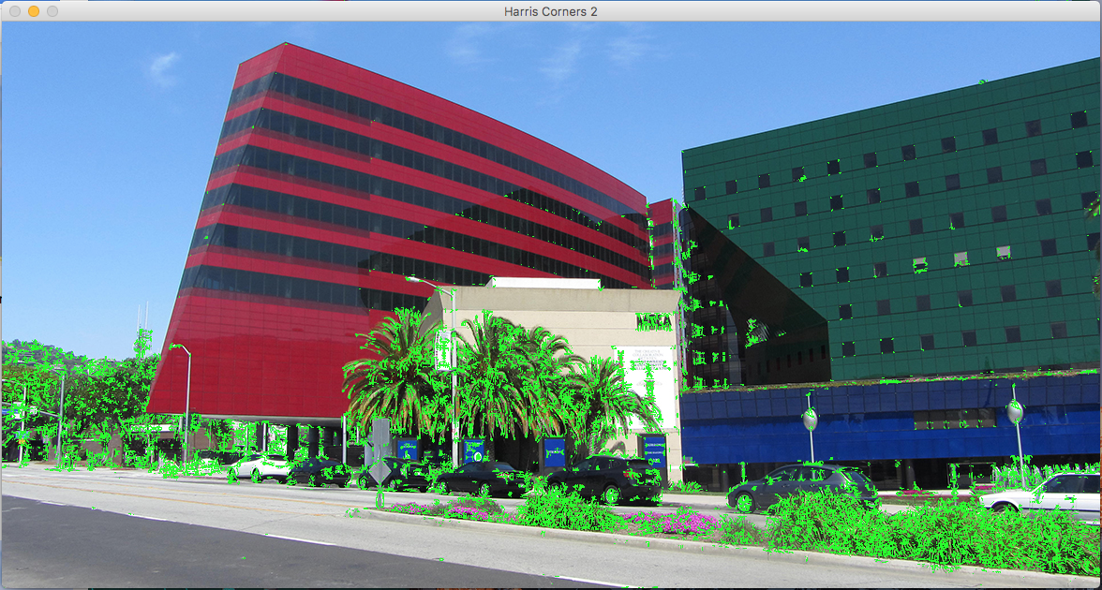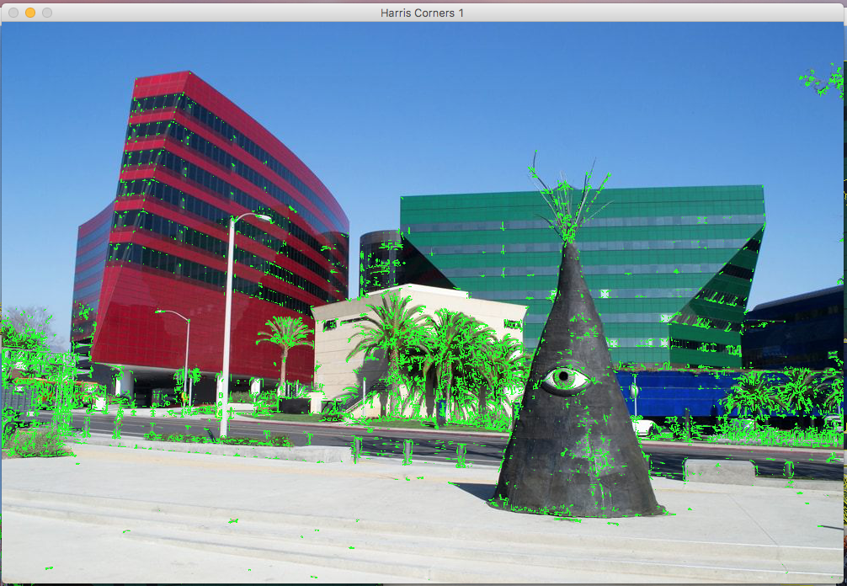Harris Corners
3. SIFT

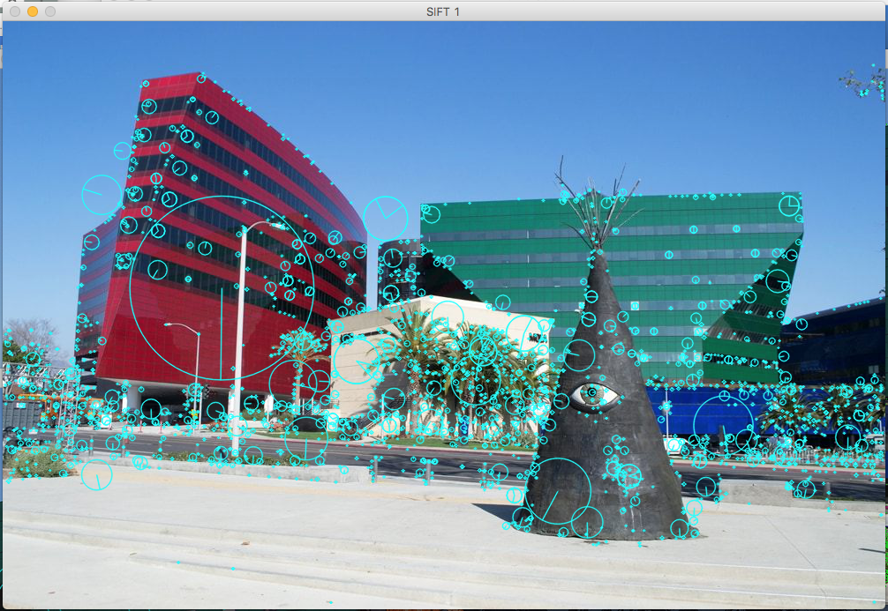

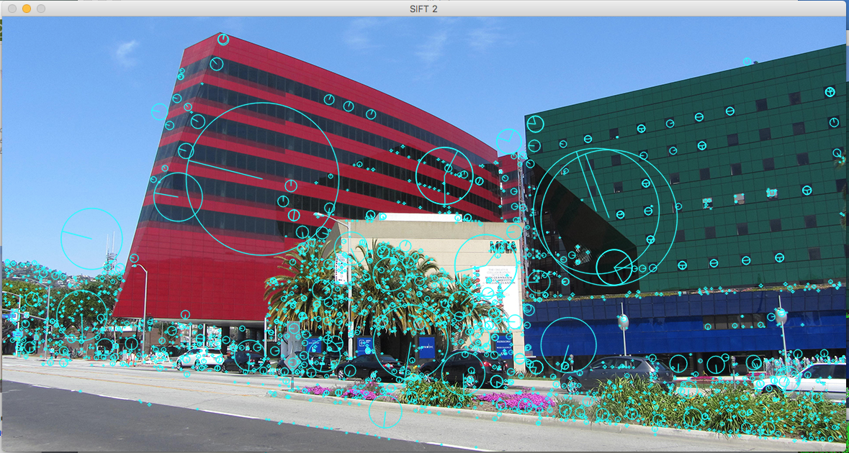

1. Comparing the Images

The features in this image seem to be compact since the number of blobs is not even close to the number of pixels. This applies for both perspectives of this building. Since there are some differences in what is in the frame of each image, the repeatability between the two is not the best. There are some similarities with the large red building, windows in the green and the trees towards the bottom. Since the trees in front of the building are all different shades (thanks to the shadows) the program finds this to have the most corners. Because of this, it is essentially ignoring the buildings (which is the point of this). I did some alteration to the threshold multiplier in the Harris Corners experiment (0.01 🡪 0.001) which captured more of the buildings.